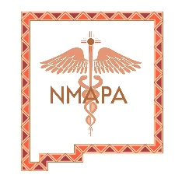 New Mexico Academy of Physician Assistants
P.O. Box 40331 Albuquerque, New Mexico 87196-0331
nmphysicianassistant@gmail.com

April 27, 2021

The New Mexico Academy of Physician Assistants (NMAPA) invites you to participate as an exhibitor or supporter at our continuing medical education conference: NMAPA Annual Primary Care Conference on September 23-25th, 2021 at the Marriott Uptown Hotel (Louisiana and I-40) in Albuquerque, New Mexico. http://www.nmapa.com

We anticipate about 100 attendees, including physician assistants and nurse practitioners from all over New Mexico and surrounding states and representing all areas of medicine.

If you have supported us in the past, thank you! We hope to see you again this year.

If you haven’t, come see what a difference direct contact with dozens of your end customers can make. There are many benefits to being a supporter, including:

Creating Positive Image
Often companies are looking to improve how they are perceived by their target audience. Championing events that appeal to their market are likely to shape buying attitudes, help generate a positive reaction, and create a heightened visibility of products/services. Additionally, attendees see you as making a greater effort to support to the event, often allowing more or better activities to take place as a result of your contribution.

Differentiating from Competitors
The mere act of supporting an event is a significant way to create competitor differentiation. Your company name has the opportunity to stand out above the competition. It is a very cost-effective form of advertising directly to the customer.

Enhance your “Corporate Citizen” Role
Funding helps you be viewed as a “good neighbor.” To be seen supporting the local community and contributing to its economic development is extremely powerful and creates enormous goodwill.

Attached is a form outlining our exhibitor and support packages. We would sincerely appreciate your backing for our continuing medical education activities and look forward to hearing the latest information you can provide on your organization's products or services.

Respectfully,

Tina Salas
Chapter Administrator

